ICA News letter, 2003-2004

Small Molecule Crystallographic Research at Indian Institute of Science, Bangalore – An Overview
T.N. Guru Row
Solid State and Structural Chemistry Unit,
Indian Institute of Science, Bangalore 560012

Abstract:
A brief report of the activities of the CCD facility setup under the IRHPA support from DST, India is presented. The installation is established at the Chemical Sciences Division since January 2002 and has facilitated structure determination of over 700 compounds of varying complexity. This article gives a glimpse of the overall impact made by this facility on the research contributions made in the last couple of years in the broad area of small molecule crystallography from Indian Institute of Science, Bangalore.

Introduction:
The research program for Chemical Sciences Division essentially involves structure determination of inorganic systems ranging from metal hydrides, Cu I and Cu II complexes, Calixarenes and Phosphazenes and related metal complexes, organic frameworks depicting biological activity like for example Otteliones (anti-tuberculosis), antibiotic diterpene Guanacastpene A and frameworks generating novel reaction pathways, Cholic acid framework structures, structure-function correlation in inorganic solids, charge density analysis, crystal engineering and supramolecular chemistry iinvolving fluorine, materials design using novel organometallic framework.
The Bruker AXS SMART APEX system is the most recent member of the SMART CCD product line of instrumentation for single crystal X-ray diffraction and is manufactured and marketed by Bruker Analytical X-ray Systems located in Germany, Holland and the US. The CCD detector is based on a 4Kchip (Peltier cooled) and both hardware and software are from standard packages supplied with all Bruker AXS systems. In addition, the facility also has an Oxford Cryo-systems nitrogen stream setup, which allows data acquisition at low temperatures (90K for example). The system consists of a 3-axis goniometer module with SMART APEX detector, radiation safety enclosure with interlocks and warning lights, D8 controller, refrigerated re-circulator for SMART APEX detector, Computer based on windows 2000 operating system, K760 X-ray generator, video Camera, Chiller for tube cooling and Oxford Cryo-stream system with dry air unit. The entire system has been put on a 20KVA SICON on-line UPS system. The user facility consists of 3 Pentium 4/ 1.2 GHz machines, and two printers. The computers are loaded with licensed software from Bruker AXS for structure determination. The machines are linked via both intra network on campus and on ernet network. All software required for structure determination, analysis and graphics are available on these user environment.

Objectives of the project/facility:
a) To set up a facility with the state of the art machine for the elucidation of structures using single crystal x-ray diffraction.
b) To initiate new collaborative projects at the chemistry –biology and chemistry-material science interfaces.
c) To initiate new teaching and training programs in crystallography so as to ensure optimum use of the facility.
d) To set up a crystallographic program library, which will contain all the routinely used crystal solution packages, graphic display packages along with the locally developed software for specific applications.
The CCDC has been installed on one of the workstations installed in the CCD facility for users. Software for structure solution and structure refinement has also been provided to users on several PC’s installed at the facility. Graphic display programs are also available for routine plotting and color graphics for molecular and crystal structure plots are provided.

Results and Discussion
A few representative examples of structures done on this facility is illustrated. The idea is to give a flavor of the range of problems that have been addressed. Many of these structures could not have been solved, some have extremely small crystals which do not give quality diffraction on a routine 4-circle diffractometer, some will have serious absorption effects because of the contents in the unit cell, some need the accurate location of hydrogen atoms and some show phase transitions with temperature.

Crystallography of inorganic compounds, absorption, size effects:
Very small crystals (100μm) have been used and accurate absorption corrections have been applied to study a large number of crystal structures. Data collection on unstable crystals, large volume crystals have become possible in small time duration (about 8 hrs). A couple of examples are given below.
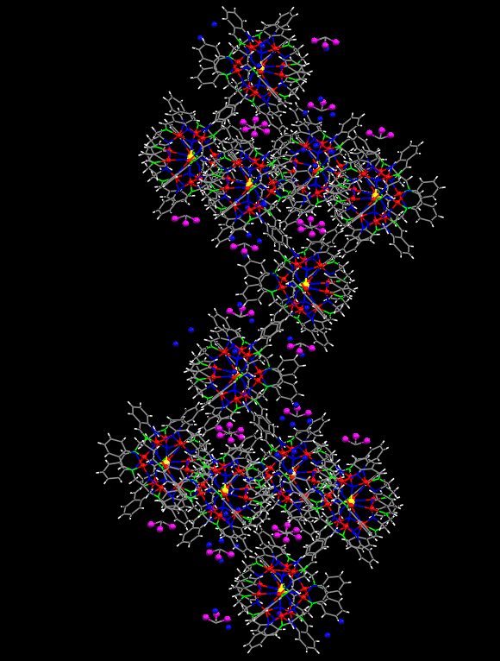
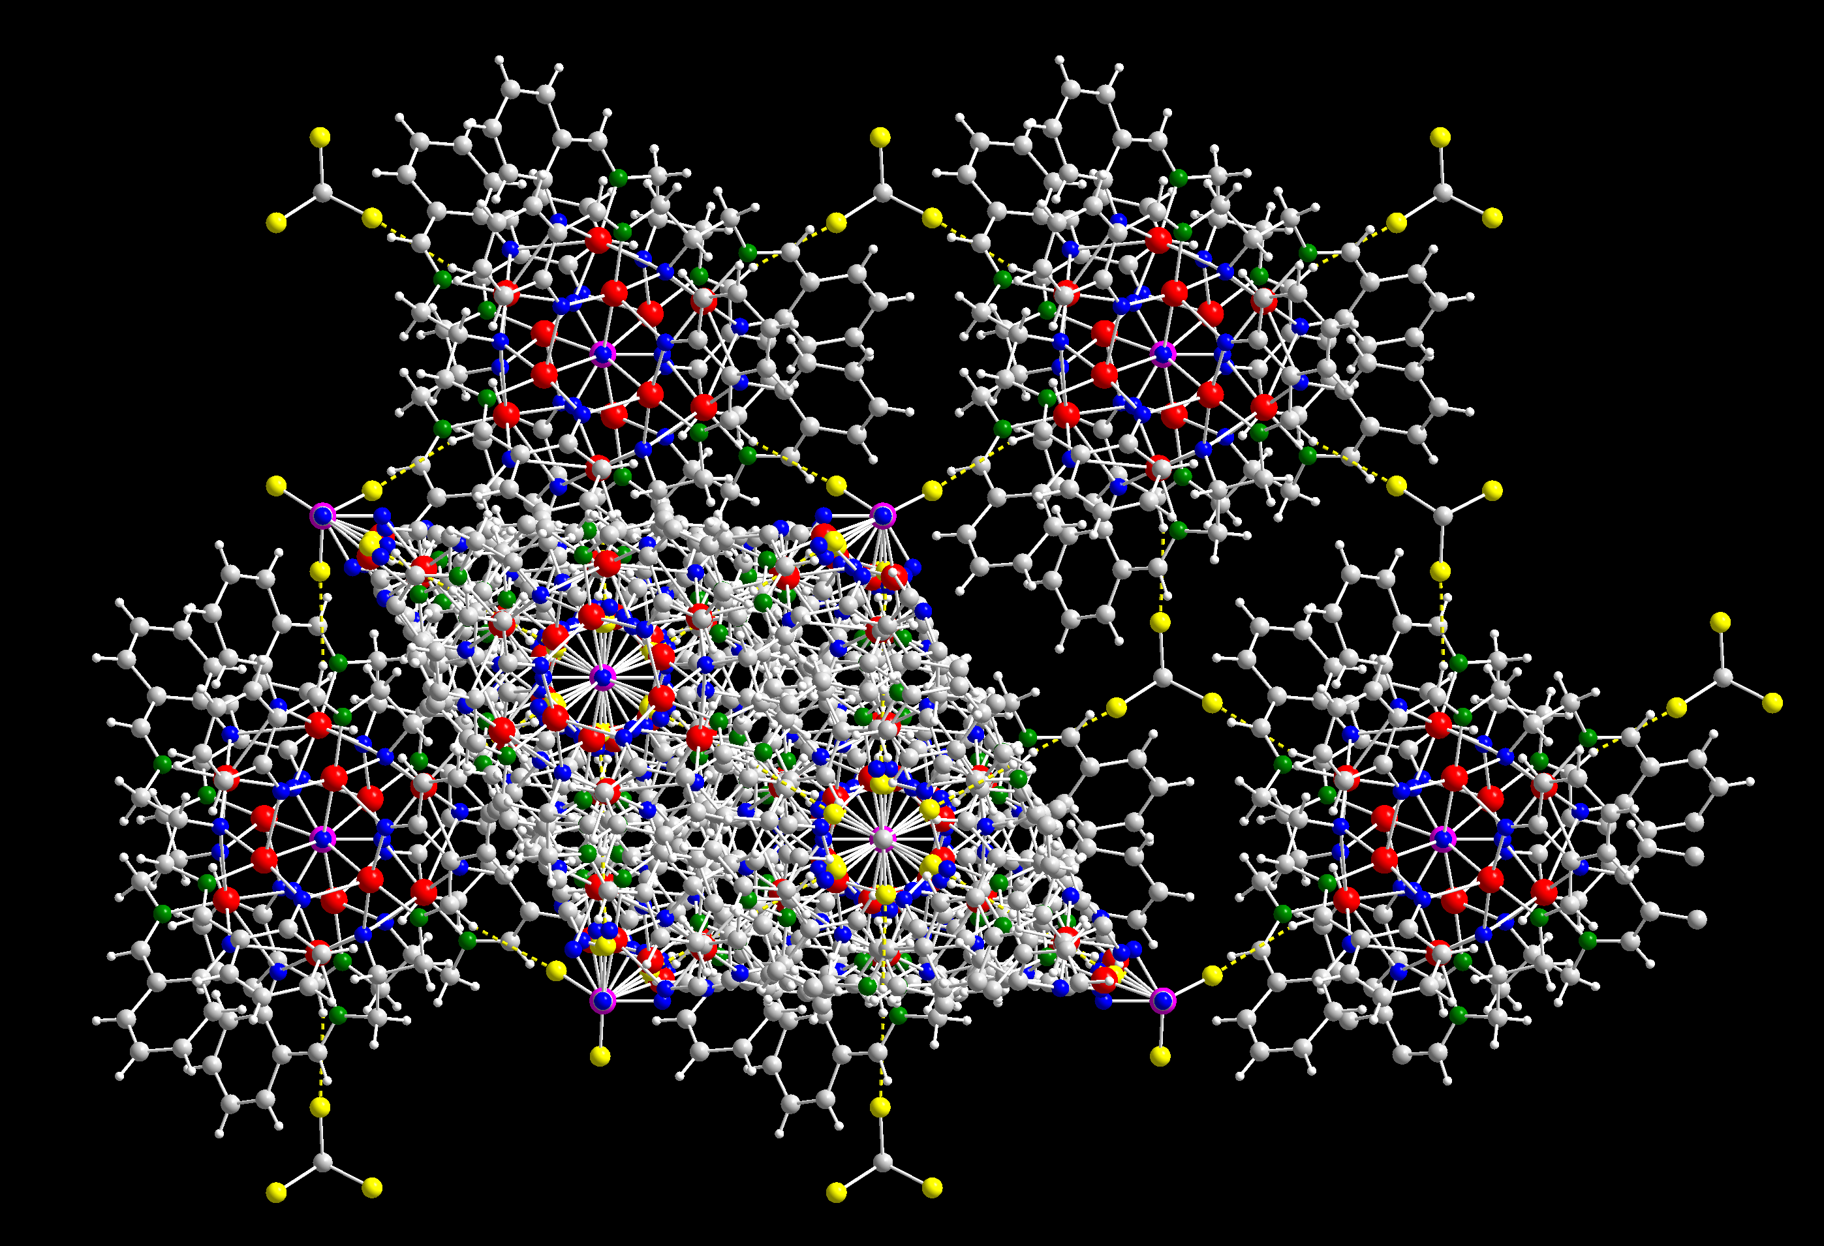

Example 1. A packing diagram of [Cu12VL6(O)5].2CHCl3.5H2O showing helical type packing with water and chloroform molecules in small cavities (a) and along c-axis showing the carbon of chloroform and the vanadium lying along the three fold axis one over the other in alternate layers (b)

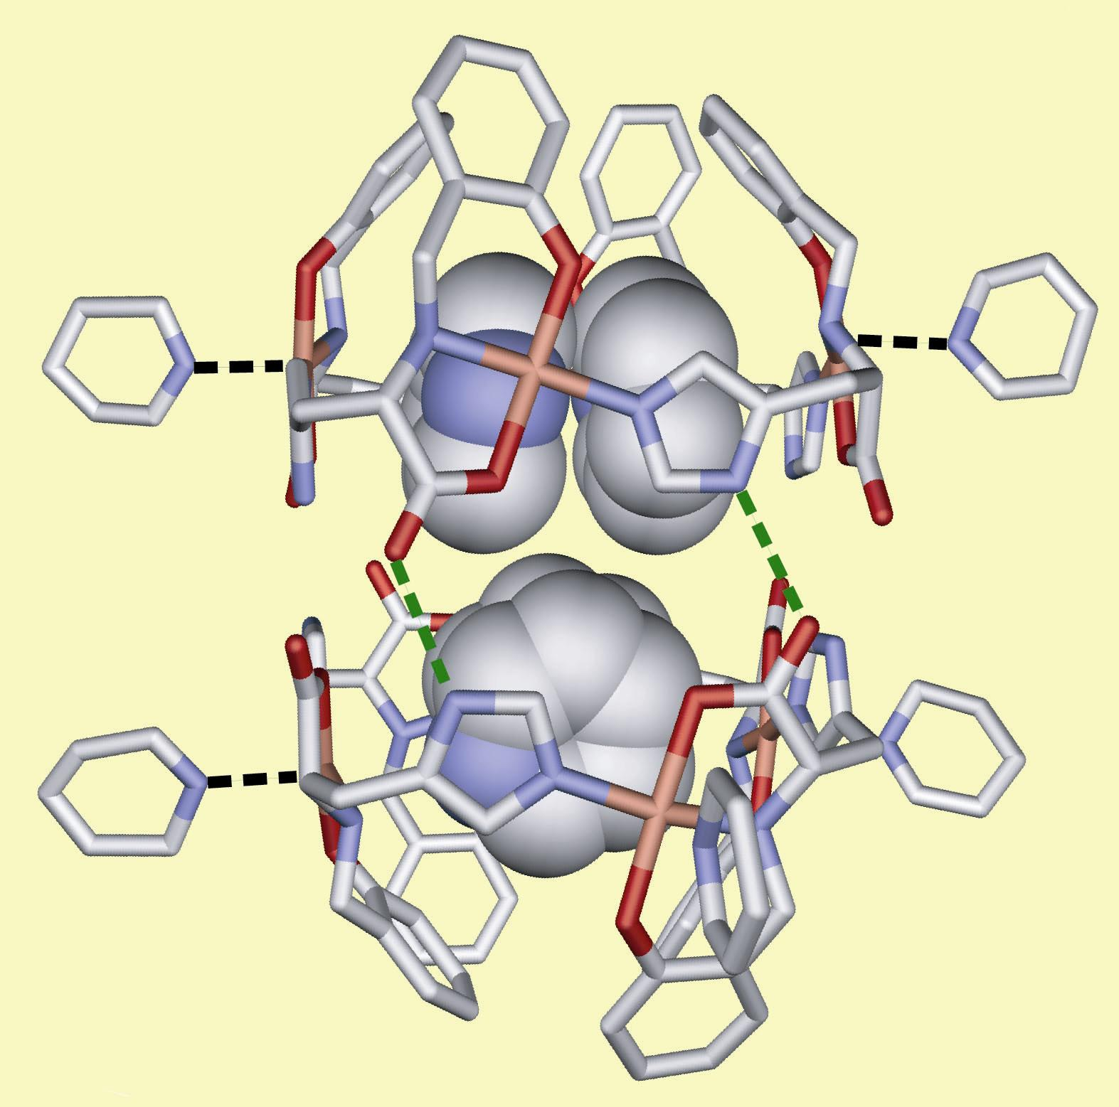
Example 2. Self-assembled Molecular Capsule that Traps Pyridine Molecules by a Combination of Hydrogen Bond and Copper(II) Coordination

Importance of hydrogen location:

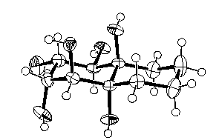
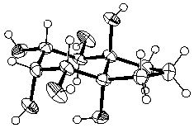
Inositols and glucoses play important roles in biological systems. Conformationally constrained inositols and carbohydrates in their native configurations have been generated and these new compounds most likely display fascinating biological profiles. Compounds like epoxyquinols (anti-cancer), guanacastepene (antibiotic), hemigeran (active against herpes virus) and agarofurans (active against multi-drug resistant bacteria) have been synthesized. Compounds have also been developed to study the fundamental aspects of many organic reactions. These are systems where the hydrogen atoms in the structures were routinely detected by difference Fourier synthesis.
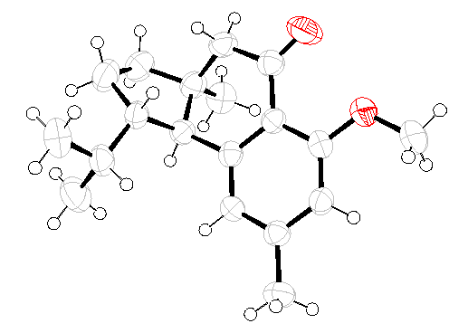
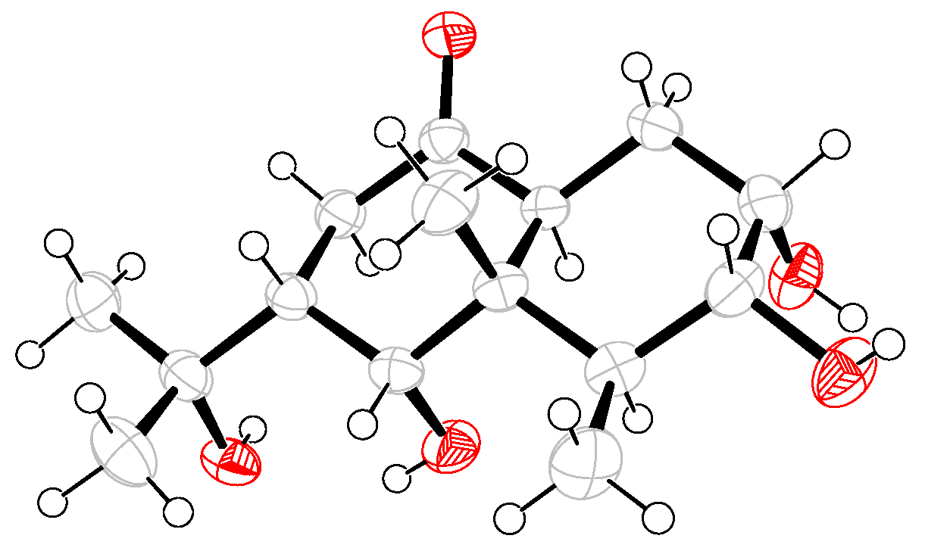
Small sized crystals and solvent location:

Design of tailor made materials using cholic acid derivatives is the basis of generating molecular mimics. Several key structures have been determined and especially the analysis of the solvent incorporation has given insights into the possible ways of evaluating the smeared electron density in cavities. Crystallography is the only approach to confirm and give a better understanding of such novel compounds. Here are some examples of the series of structures determined.

Chem. Str. Status Crystal str. (ORTEP diagram)
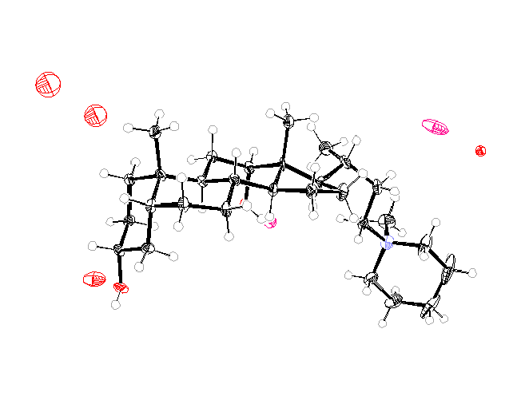
Str. Obtained completely using CCD-XRD

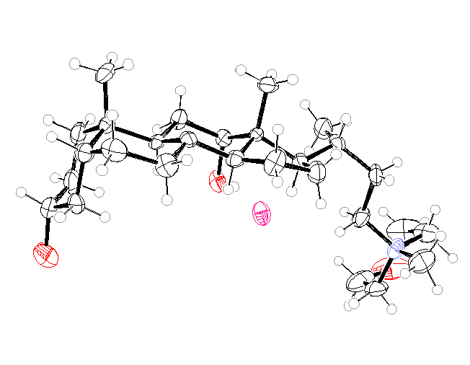

Str. Obtained completely using CCD-XRD

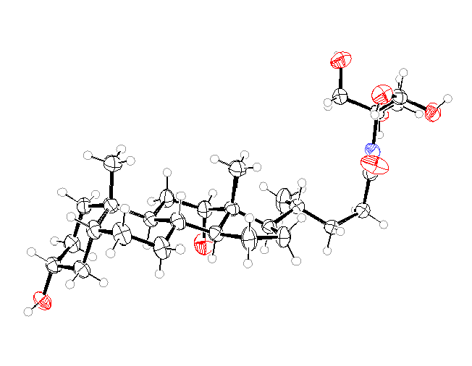

Str. Obtained completely using CCD-XRD

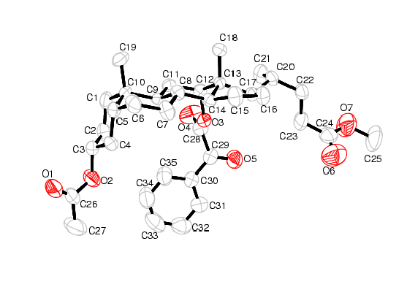

Figure 1

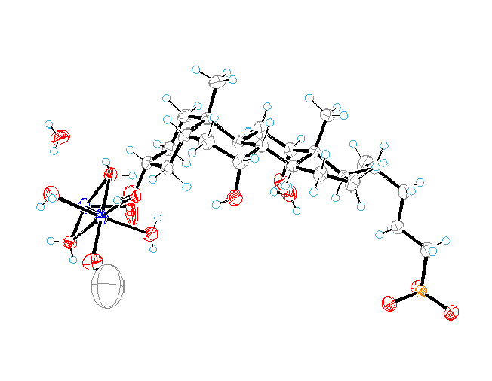
Str. Obtained completely using CCD-XRD

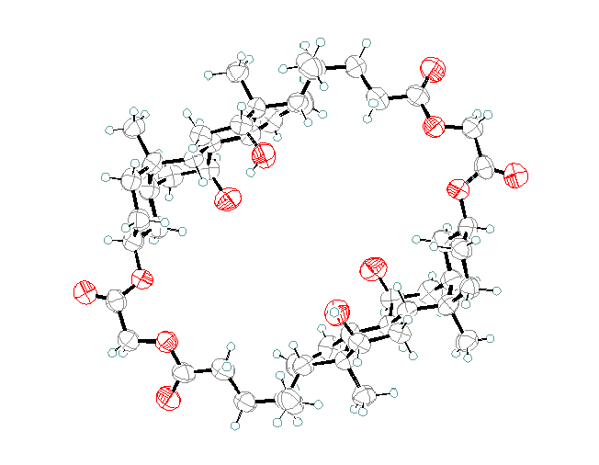
Str. Obtained completely using CCD-XRD

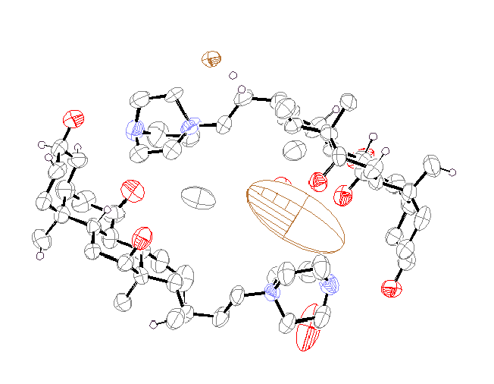
Incomplete str. to be solved at low temp.
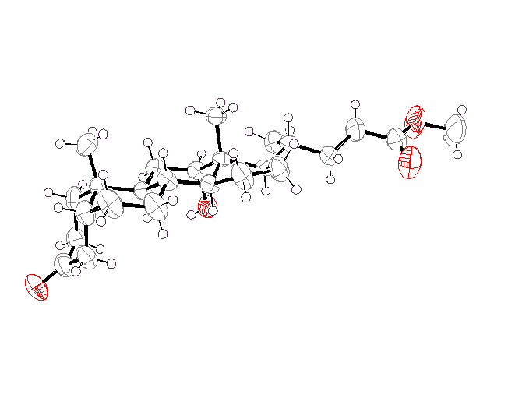
Str. Obtained completely using CCD-XRD

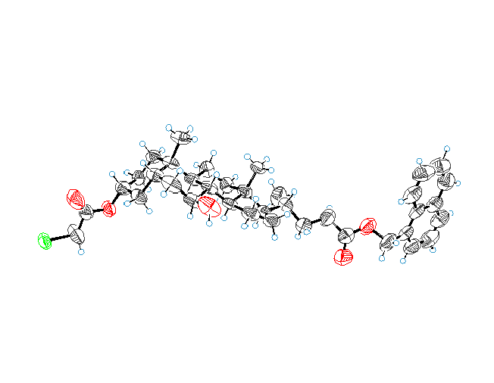

Str. Obtained completely using CCD-XRD

Crystal engineering, phase transitions and charge density:

Comparison of conformational features on halogen substitution in 1, 2-diaryl-6-methoxy-1, 2, 3, 4-tetrahydroisoquinolines based on crystal structures indicate that the derivatives with fluorine differ significantly from those of chlorine and bromine. The packing of the molecules in the lattice are nearly identical for derivatives of chlorine and bromine while the fluorine derivatives display C-F...F, C-H...F and C-F...π interactions. These structures have paved the way for the understanding of “organic Fluorine” as a crystal engineering tool.
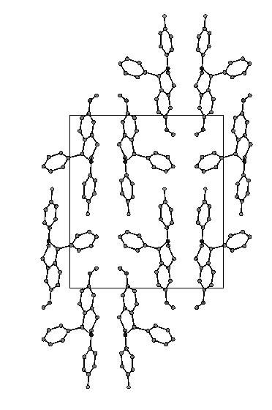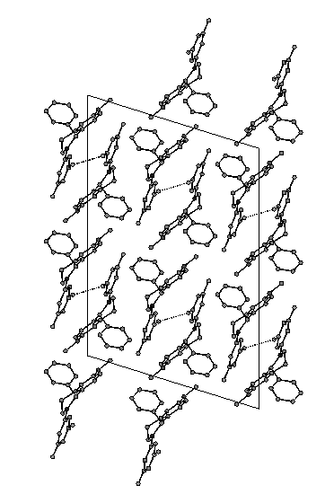
The crystal structure of the paraelectric phase of rubidium hydrogen sulfate has been redetermined at room temperature to be monoclinic with a=14.3503(14), b=4.6187(4), c=14.3933(14) Å β=118.03(1)º (space group P2₁/n) and both the sulfate groups are ordered unlike in previous reports. The crystal structure of the ferroelectric phase at 200K belongs to the noncentrosymmetric space group Pn with a=14.2667(12) b=4.5878(4) c=14.2924(12) Å β=118.01(1)º with distorted sulfate groups. The hydrogen atoms fixed at average neutron values provide evidence for the formation of O-H…O nonlinear bonds. The change in the Rb coordination is discussed in terms of bond valence sum calculations. Variable temperature powder X-ray diffraction patterns at temperatures above 393K indicate possible reduction in symmetry suggesting a phase transition.
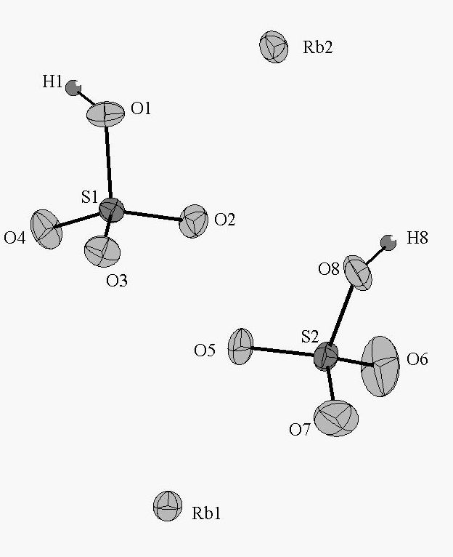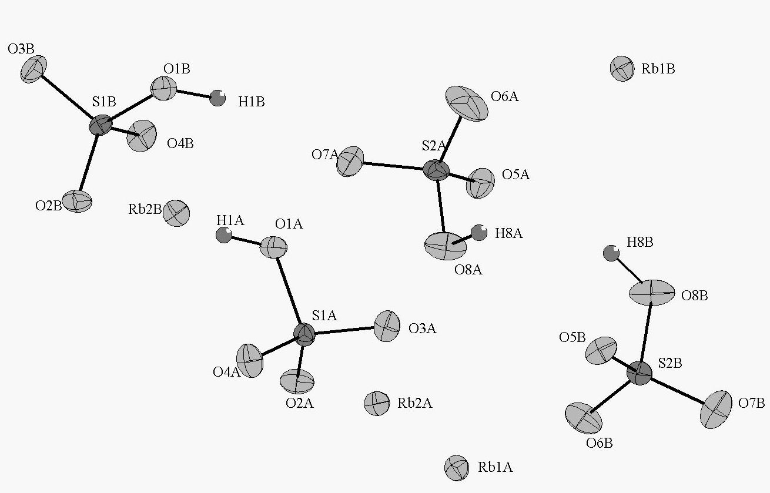

Charge density distribution in 2H-chromene-2-thione (2-thiocoumarin), C₉H₆OS has been determined by the application of the multipole model from accurate X-ray diffraction data measured at 90K using a CCD detector, to a resolution of sinθ/λ < 1.08 Å⁻¹. A multipolar atom density model was fitted against 6908 reflections with I > 2σ(I) [R(F) = 0.021, wR(F) = 0.022, g.o.f. = 1.81] to generate the difference Fourier maps. Topological properties of the molecular electron density in terms of bond critical points and the evaluation of the dipole moment show that the molecular dipole moment in the crystal is higher than the corresponding value derived from theoretical calculations.

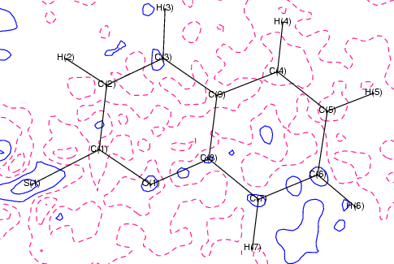Residual density drawn at contour intervals of 0.05 e/A³

Small Biomolecules:
The Research Program of the Biological Division involves the X-ray crystallographic structure determination of oligopeptides with sequence lengths of 8-13, amino acids and peptides with malonates, and peptides involving Boc groups. These results allowed a closer understanding of the conformational variability, recurring and new features of aggregation and effect of chirality in the malonic acid complexes and in understanding the conformational flexibility of amino acids.
New molecules have been synthesized to block the function of the enzymes from the malarial parasite P. falciparum with a view to determine their structure, analyze their interactions with the enzymes and design more effective inhibitors which can act as potential anti malarial compounds.
The availability of high resolution of crystal structure data on the helical structure determined in the above context with varying length, sequences, side chains and backbone modifications has provided a systematic base for understanding of heterogeneity and stability of helices, helical transition, reversal, termination, hydration and solvation of helices, unfolding of helices, helix orientation and mode of assembly of helices in peptide crystals. While in the malonic amino acids the reversal of the chirality leads to a fundamentally different aggregation pattern. An example is shown below.
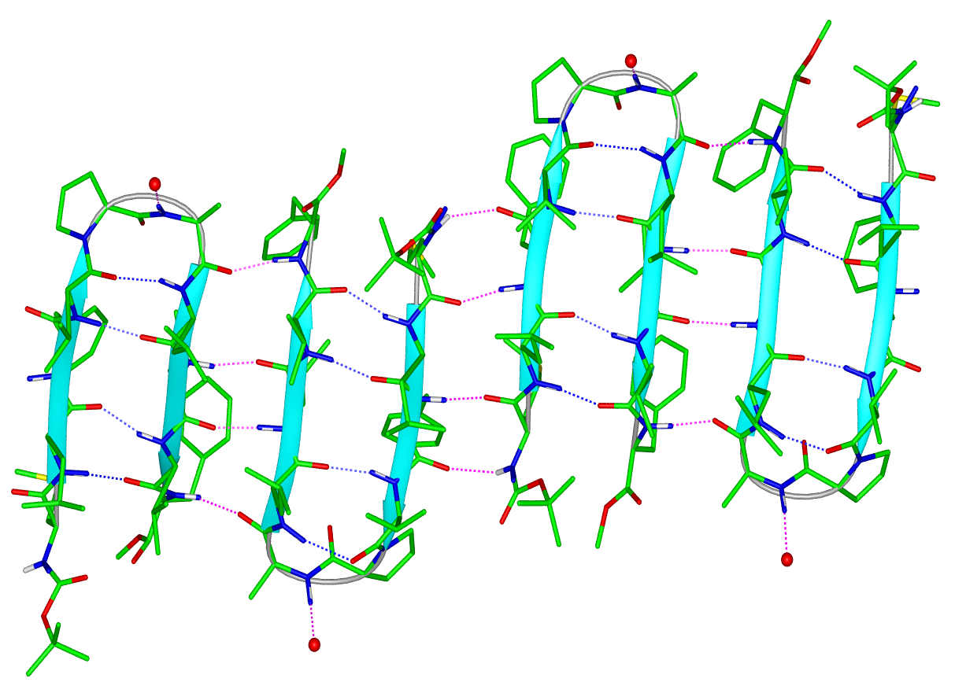
A
B
C
D

