ICA News letter, 2003-2004

Lead Discovery and Drug-Design Through X-ray Crystallography
Bindu Pillai and M.V. Hosur
Solid State Physics Division,
Bhabha Atomic Research Centre, Trombay, Mumbai – 400085.

Abstract
Hexagonal crystals of unliganded tethered HIV-1 protease combined with the soaking method for the preparation of the complex, have been shown to be suitable for rapid development of HIV-1 protease inhibitors as drugs against AIDS. This strategy has been used to identify chemical modifications needed for enhancing the inhibition-potency of a coumarine derivative lead.

Introduction
Increases in the speed and accuracy of X-ray diffraction data collection on crystals of biological macromolecules has spawned the interdisciplinary field of structure-based drug-design. In this technology, interactions between a small molecule ligand and its macromolecular receptor are optimsed through an iterative process of chemical synthesis, structure determination of the complex and biochemical testing. One of the successful application of this technology has been in the development of drugs against AIDS. Within a short period of less than a decade, six inhibitors of HIV-1 protease (HIV-1 PR) enzyme developed via structure-based drug-design, have reached the market place and are being used in AIDS therapy (Wlodawer & Vondrasek, 1998, Tomasselli & Heinrikson, 2000). However, because of the emergence of drug resistant strains of HIV-1 PR, there is a constant demand for chemically diverse types of protease inhibitors. To meet this demand there is a need for rapid turnover of 3D structures of HIV-1 PR-inhibitor complexes in crystalline form, prepared either by cocrystallisation or by soaking. Attempts at co-crystallization may not always succeed, and this is could become a serious handicap in rapid discovery of lead compounds. On the other hand, for the soaking method to succeed, the ligand binding region on the enzyme should be accessible from the solvent channels in the crystal. So far crystals of ligand-bound HIV-1 protease have all been prepared by the co-crystallisation method, since there is a substantial difference in the conformation of unliganded and liganded HIV-1 protease whose structures had been determined earlier (Wlodawer & Erickson, 1993). In particular tips of the flap region move by as much as 7Å( Figure 1) to interact with the substrate or inhibitors, and therefore tetragonal crystals of HIV-1 PR ( Navia et al, 1989, Wlodawer et al, 1989, Lappatto et al 1989, Spinelli et al, 1991) are not suitable to prepare crystals of complexes by the soaking method. We have recently reported crystals of unliganded tethered HIV-1 PR ( Pillai et al, 2001), in which the flap conformation is identical to that found in ligand-bound structures, thus opening up the possibility of using the soaking method for rapid screening of potential lead compounds. We report here the crystal structure of acetyl-pepstatin tethered HIV-1 PR complex obtained by the soaking method and compare this structure with the structure of the same complex obtained earlier by co-crystallization, and demonstrate the applicability of the method proposed here for rapid discovery of compounds that bind in the active site cavity. We also describe the structure of the complex of HIV-1 protease with a coumarine derivative lead.
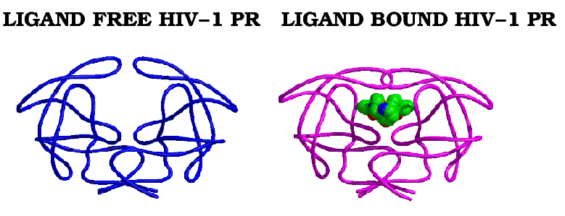
Figure 1. Conformational difference between ligand-bound and unliganded HIV-1 PRs. (The ligand free and ligand-bound HIV-1 PR are shown in blue and pink respectively, with the bound inhibitor in green).

Methods:
Tethered HIV-1 protease enzyme was overexpressed in BL21[DE3] cells, extracted in denatured form, refolded and then purified as described in Pillai et al. (2001). Hexagonal crystals of unliganded tethered HIV-1 protease were grown in hanging drops at room temperature by the vapour diffusion method. Native crystals were soaked for varying periods of time, determined by trial and error, into solutions of the ligand molecules. Most ligands are hydrophobic in character and have poor solubility in aqueous buffers. Diffraction data ware collected on the inhouse RAXIS-IIC imaging plate diffractometer mounted on a RU200HB X-ray generator equipped with confocal optic to focus X-rays. While oscillation data processing was using DENZO software package (Ottowinsky 1993), structure refinement was using the software package CNS (Brunger et al. 1998). Electron density interpretation and molecular analysis was through the graphics software package O (Jones et al. 1991). All figures were generated using softwares Bobscript (Esnouf 1997) and Raster3D (Merritt et al. 1994).

Results:
The structure of acetyl-pepstatin-tethered HIV-1 PR complex has been determined to a resolution of 2.4Å. All the six residues of acetyl-pepstatin (ACE-VAL-VAL-STA-ALA-STA) are clearly defined in the 2Fo-Fc electron density map. Acetyl-pepstatin is bound in an extended conformation in the active site cavity of tethered HIV-1 PR, interacting with the active site residues through hydrogen bonds and van der waals interactions (Fig 2 & Table I).

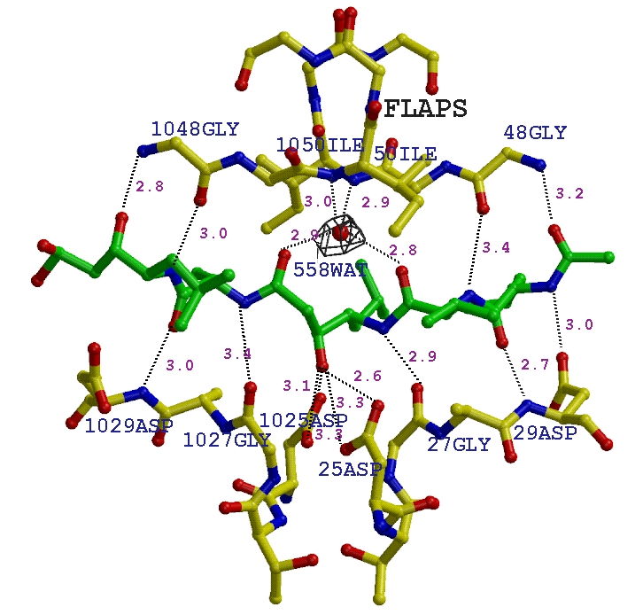
Figure 2. Hydrogen bonding interactions of acetyl-pepstatin (green) bound in the active site cavity of HIV-1 PR (yellow). The electron density corresponding to the water molecule 558 hydrogen bonded to the amide nitrogens of residues 50Ile and 1050Ile of the flaps on one side and inhibitor atoms on the other is also shown.

Table 1. Residues of HIV-1 PR which are involved in non bonded interactions (< 4.2A) with the bound acetyl-pepstatin. .
Acetyl-pepstatin residues | Residues from HIV-1 PR
Ace-1 | 29Asp 30Asp, 47Ile, 48Gly
Val-2 | 29Asp, 30Asp, 48Gly, 1008Arg
Val-3 | 27Gly, 28Ala, 29Asp, 30Asp, 47Ile, 48Gly, 1050Ile
Sta-4 | 25Asp, 27Gly, 1025Asp, 1027Asp, 50Ile, 1027Gly, 1049Gly
Ala-5 | 1027Gly, 1028Ala, 1029Asp, 1048Gly
Sta-6 | 8Arg, 81Pro, 82Val, 1027Gly, 1029Asp, 1047Ile, 1048Gly, 1030Asp

The structures obtained by co-crystallization (Fitzgerald et al, 1990, pdb id 5hvp) and by soaking (present study) were compared to examine if the interaction between the protein and inhibitor were similar in the two modes of preparation of the complexes. The overall bound conformation of the inhibitor is essentially the same for both ( RMSD of 0.2Å) with few minor variations in side chain atoms. The side chain of the terminal statine was found to deviate from its position in the cocrystallized structure perhaps to relieve short contact between CD1 (Sta-6) and CD1 ( 82 Leu ) of 2.8Å and another one of 2.1Å between OH (Sta-6) and O (1048 Gly). The RMSD over the 198 Cα atom pairs used in the comparison was 0.6Å, which is within the range of values found when the same molecular structure is solved in different crystallographic space groups. The interactions between acetyl-pepstatin and the protein residues were also similar in the soaked and the co-crystallized structures (Figure 2).

Table II. Non peptidic compounds (1-5) used for soaking in crystals of HIV-1 PR.
Sr.No | Name assigned to the inhibitor | Structural formula
1.  2.  3.  4.  5. | I1  I2  I3  I4  U01 | 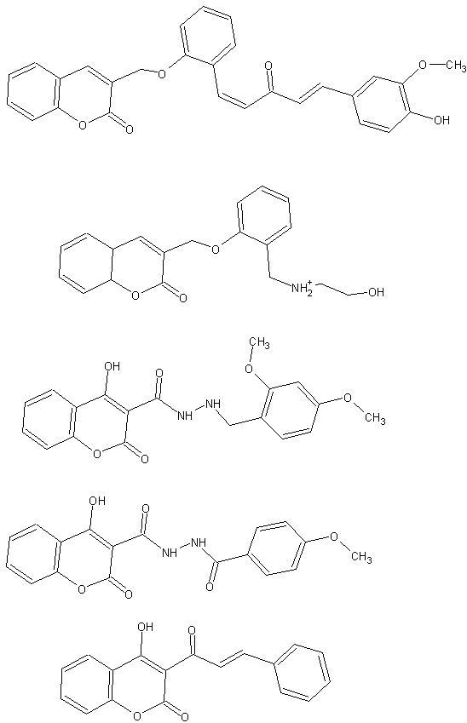

Having thus established the applicability of this method, a series of coumarin based inhibitors synthesised by our collaborators at UDCT, Mumbai and IIT, Mumbai, were taken up for lead discovery and development. Crystals of unliganded protease were soaked in solutions of compounds listed in Table 2. X-ray structures for all five potential complexes were determined by the molecular replacement method. Unambiguous electron density in the active site cavity was observed corresponding to only one compound, namely U01 (Table 2-item 5). Crystals of unliganded HIV-1 PR soaked for 24 hours in a 1mM solution of the lead compound U01 diffracted to a resolution of 2.3Å. These crystals were isomorphous with the crystals of the unliganded enzyme, permitting structure determination by direct refinement using the program CNS (Brunger et al, 1998). A schematic representation of hydrogen bonding interactions of U01 with the protein residues is illustarted in Figure 3. The compound U01 spans the S1-S2’ subsites of the protease dimer, with its fused phenyl ring oriented in the S1 site and flexible side chain extending to the S2’ site of the enzyme. The water molecules present in the active site cavity of unliganded HIV-1 PR are seen to be displaced by atoms from U01 in the present structure. The position of U01 molecule in the active site cavity appears to be determined by hydrogen bonds involving polar oxygens on the coumarin ring. The polar functional groups from U01 are engaged in hydrogen bonding interactions with active site aspartates on one side and flap residues on the other. The 4-hydroxyl group (OB8) on the coumarin ring of U01 is located between the catalytic aspartates at distances of 2.6Å and 2.8Å from the OD2 atoms of 25Asp and 1025Asp respectively, thereby displacing the catalytic water. The two oxygens of the lactone ring (OA1 and OB3) are engaged in hydrogen bonds to the amide nitrogens of residues 50Ile and 1050Ile of the flaps, replacing the conserved flap water (wat301) present in all the peptidic inhibitor complex structures of HIV-1 PR (see also Figure 2). In addition binding of U01 with HIV-1 PR is characterized by many Van der waals interactions with protein residues lining S1-S2’ subsites of the enzyme. Using a cutoff distance of 4.2Å, the inhibitor is found to form a total of 60 favorable Van der waals contacts with the protein residues 23Leu, 50Ile, 81Pro, 82Val, 84Ile, 1023Leu, 1048Gly, 1049Gly, 1081Pro, 1082Val and 1084Ile in the active site cavity. This structure of the complex would form the basis for suggesting chemical modifications to the lead compound that could further optimise binding.
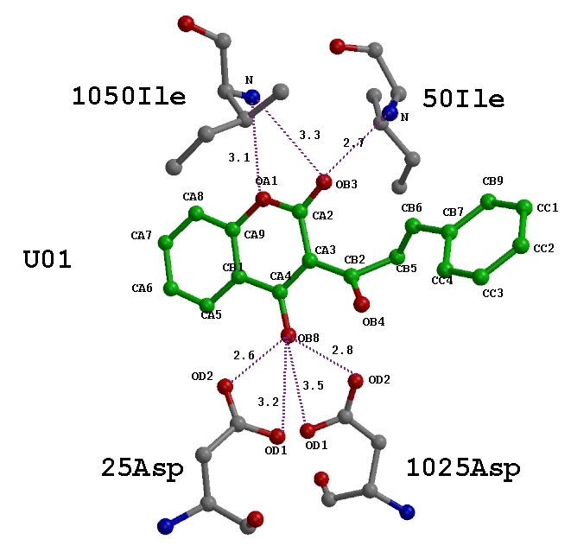
Figure 3. Hydrogen bonding interactions of U01 (green) with the protein residues (grey) of HIV-1 PR. The oxygen and nitrogen atoms are shown in red and blue respectively.

Our studies revealed that a hydroxyl group at CA4 position on the coumarin ring, which was involved in hydrogen bonding interactions with the active site aspartates is critical for binding to the active site of HIV-1 PR. It is not clear why compounds I3 and I4 (Table 2), which also contained a 4-hydroxyl group on the coumarin ring did not bind at the active site of HIV-1 PR. One possible reason could be their poorer solubility under the conditions used for soaking.

In conclusion, it has been shown that in the closed flap hexagonal crystals the active site of tethered HIV-1 PR is accessible to the ligand and that acetyl-pepstatin, a known inhibitor of aspartyl proteases can diffuse into these crystals and bind at the active site in a way similar to that observed in the co-crystallised structure. This method can also be applied for very fast de novo identification of potential lead compounds, where getting crystals of the complex is a bottleneck in the method of co-crystallization. Thus the soaking method reported here allows for rapid screening through X-ray diffraction to accelerate the iterative process of structure-assisted drug design against AIDS.

References
- Brunger AT, Adams PD, Clore GM, Delano WL, Gros P, Grosse-kunstleve RW, Jiang JS, Kuszewki J, Nilges M, Pannu NS, Read RJ, Rice LM, Simonson T, Waren GL. (1998), Crystallography and NMR system : A new software suite for macromolecular structure determination . Acta Cryst D, 54, 905-921.
- Esnouf R. M. (1997). An extensively modified version of molscript that includes greatly enhanced coloring capabilities. J. Mol. Graphics 15, 132-134.
- Fitzgerald PMD, Mckeever BM, VanMiddlesworth JF, Springer JP, Heimbach JC, Leu CT, Herber WK, Dixon RAF, Darke PL. (1990). Crystallographic analysis of a complex between Human immunodeficiency virus type 1 protease and actyl pepststin at 2.0Å resolution. J. boil. Chem.. 265, 14209-14219.
- Jones TA, Zou JY, Cowan SW, Kjeldgaard M. (1991).Improved methods for building protein models in electron density maps and the location of the errors in these models. Acta Crystallographica A 47, 110-119.
- Lapatto R., Blundell T., Hemmings A., Overington J., Widerspin A.M, Wood S., Merson J. R., Whittle P. J., Danley D. E., Geoghegan K, F, hawrylik S., J., Lee S. E., Scheld K., and Hobart P. M. (1989). X-ray analysis of HIV-1 proteinase at 2.7A resolution confirms structural homology among retroviral enzymes. Nature, 342, 299-302.
- Merritt, E. A. & Murphy, M. E. P. (1994). Raster3D version 2.0. A program for photorealistic molecular graphics. Acta Cryst., D50, 869-873.
- Navia M. A., Fitzgerald P. M. D., Mckeever B. M., Leu C. T., Heimbach J. C., Herber W. K., Sigal I. S., Darke P. L. and Springer J. P(1989). Three-dimensional structure of aspartyl protease from human immunodeficiency virus HIV-1 Nature, 337, 615-620.
- Ottowinsky Z.(1993) Oscillation data reduction program in : Data collection and processing.pp-56-62, Proceedings of the Daresbury CCP4 study weekend.compiled by . : Sawyer L, Isaacs N, Baily S.
- Pillai B., Kannan K. K., Hosur M. V. (2001). 1.9Å X-ray study shows closed flap conformation in crystals of tethered HIV-1 PR. Proteins Struct. Func. Gen. 43, 57-64.
- Spinneli S., Liq Q. Z., Alzari P. M., Hirel P. H., and Poljak R. J. (1993). The three dimensional structure of the aspartyl protease from the HIV-1 isolate BRU. Biochimie, 73, 1391-1393.
- Tomasselli AG, Heinrikson RL. (2000). Targeting the HIV protease in AIDS therapy: a current clinical perspective. Biochim. Biophy. Acta, 1477, 189-214.
- Wlodawer A., Erickson JW. (1993) Structure based inhibitors of HIV-1 protease. Annu. Rev. Biochem. 62, 543-585.
- Wlodawer A., Miller M., Jaskolski M., Sathyanarayana B. K., Baldwin E., Weber I. T., Selk L. M., Clawson L., Schneider J. and Kent S. B. H (1989). Conserved folding in retroviral proteases : Crystal structure of syntheic HIV-1 protease . Science, 245, 616-621.
- Wlodawer A., Vondrasek J. (1998). Inhibitors of HIV-1 protease: a major success of structure- assisted drug design. Annu. Rev. Biphys. Biomol. Struct., 27, 249-284.

