ICA News letter, 2003-2004

Structural Biology at the All India Institute of Medical Sciences, New Delhi
The Structural Biology Group at the Department of Biophysics, All India Institute of Medical Sciences is working on a number of biological systems with a specialized focus on rational structure based drug design employing the approaches of molecular biology, protein chemistry, X ray diffraction, peptide design, molecular modeling etc. to achieve the goals. An overview of the projects currently in progress is given below:

- Lactoferrins
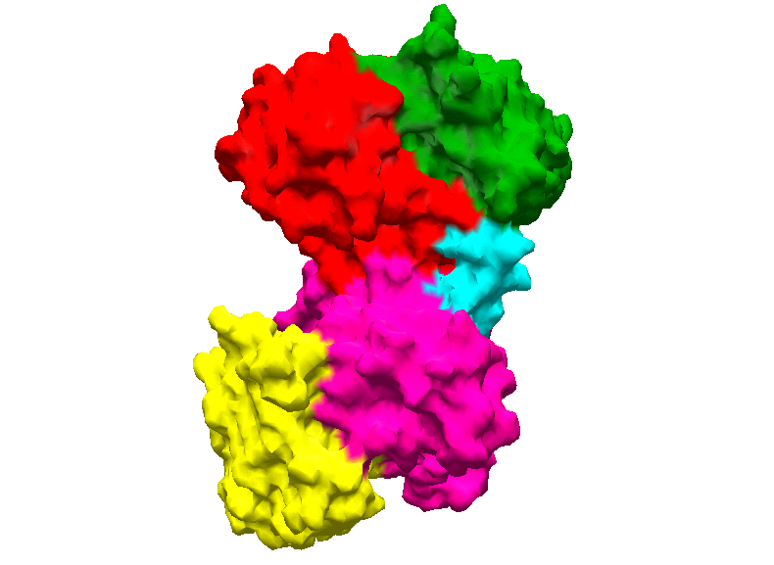
Lactoferrin, a natural defence iron-binding protein, has been found to possess antibacterial, antimycotic, antiviral, antineoplastic and anti-inflammatory activity. The protein is present in exocrine secretions that are commonly exposed to normal flora: milk, tears, nasal exudate, saliva, bronchial mucus, gastrointestinal fluids, cervico-vaginal mucus and seminal fluid. Lactoferrin is an iron binding glycoprotein with a molecular mass of 80 kDa. A principal function of Lactoferrin is that of scavenging free iron in fluids and inflamed areas so as to suppress free radical-mediated damage and decrease the availability of the metal to invading microbial and neoplastic cells. It consists of a single polypeptide chain of about 680-700 amino acid residues to which one to four glycans are attached through a N-glycosidic linkage . It serves a general role of controlling the level of free iron and possibly other elements in the body fluids of animals by sequestration of the bound metal ion. It binds reversibly two ferric ions together with two carbonate ions. The structural biology group at All India Institute of Medical Sciences has determined over 25 structures of lactoferrins in diferric, iron-free and complexed forms from six species.

- Endothelin Receptor
Cardiovascular diseases are among the major killers in the present day industrialized society all over the world. Despite the availability of therapeutic agents and approaches to combat the menace of cardiovascular ailments, there is still a serious question about their desired efficacy and thus there is a need to design new molecules The best approach to new drug discovery today is the structure based design. In view of this, we have identified endothelin receptor is the most suitable target because it causes vasoconstriction upon binding of a 21-residue endothelin peptide. In normal circumstances the binding of endothelin peptide to endothelin receptor is a physiological process. However, its excess binding becomes causative agent of heart ailment. In order to develop an effective antagonist, it is necessary to determine the three-dimensional structure of endothelin receptor. On understanding the binding properties and structural details of the binding site of endothelin receptor, a suitable molecule which is structurally and chemically complementary to the binding surface of the endothelin receptor. Therefore, we are pursuing this work which involves cloning of endothelin receptor, its crystallization structure and working out the details of the binding domain. Based on these details, the design of specific inhibitors using  -dehydro residues is being carried out.

3. Phospholipase A₂
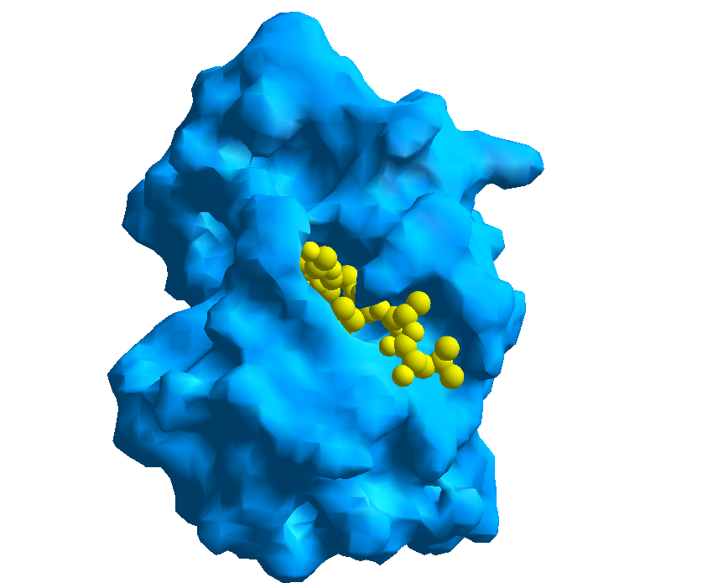
There is another area of great interest where no effective therapeutic agents are available and that is inflammatory disorders including rheumatism and arthritis. The cascade reaction which produces eicosanoids - the substances that are responsible for inflammation is catalyzed by several enzymes at different steps. The two most important steps occur due to enzymes phosopholipases A₂ and cyclo-oxygenases I and II. These two sets of enzymes constitute attractive targets in the rational design of anti-inflammatory agents. Therefore, we have initiated a detailed programme of three dimensional structure determination of phosopholipases A₂ and cyclo-oxygenase. The work on the design of specific inhibitors of these enzymes is also in progress. So far, the structures of several isoforms of PLA₂s from different species and a number of their complexes with natural and designed inhibitors have been completed already.

4. Disintegrins
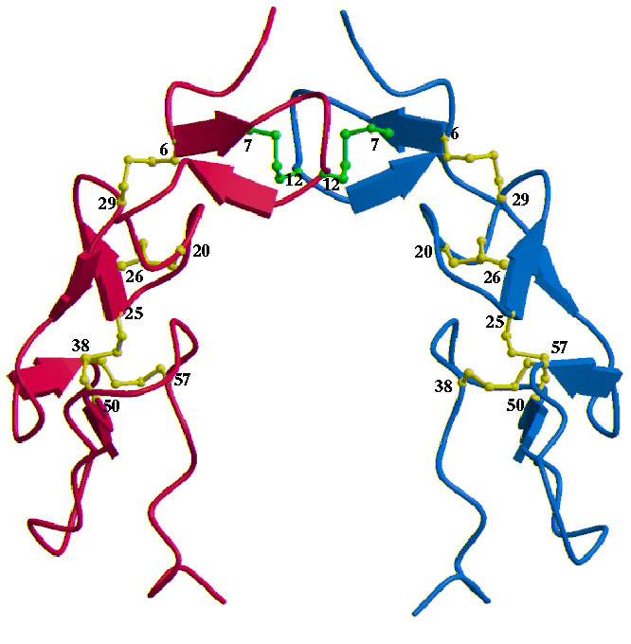
Disintegrins are found in the venoms of various snakes of the viper family, that inhibit the function of some integrins of the b 1 and b 3 classes. They were first identified as inhibitors of platelet aggregation and were subsequently shown to bind with high affinity to integrins and to block the interaction of integrins with RGD-containing proteins. Disintegrins are effective inhibitors at molar concentrations 500-2000 times lower than short RGDX peptides. They are cysteine-rich polypeptides ranging from 45 to 84 amino acids in length and almost all of them have a conserved -RGD- sequence on a -turn, presumed to be the site that binds to integrins. We have purified, crystallized and determined the structure of Echistatin, a homodimeric disintegrin with a molecular weight of 14 kDa from Echis carinatus venom which is a potent antagonist of alpha4 integrins. This is the first three-dimensional structure derived from crystallographic data on a disintegrin molecule from any source.
N
N
C
C

5. Matrix Melanosomal Proteins
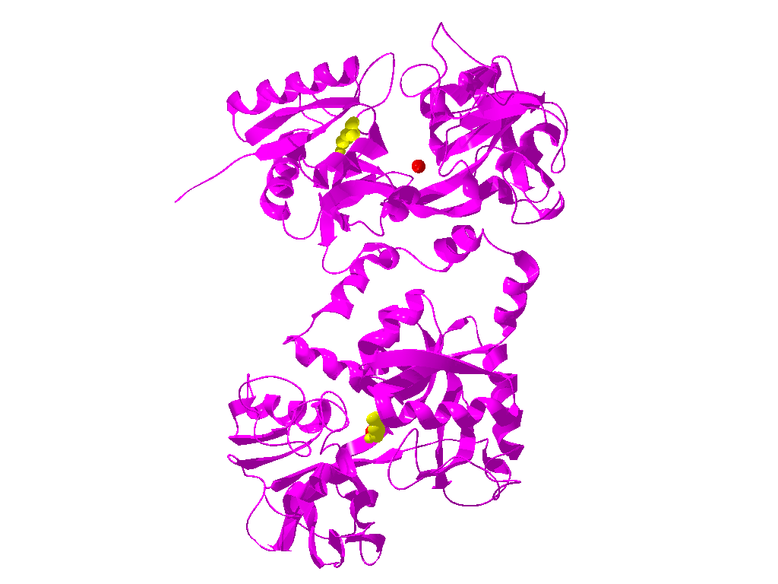
We are also working on the system of melanosomal proteins. There are about 11-17 melanosomal proteins present in melanosomal tissues. These proteins are assumed to be involved in the melanin polymerization. The degree and concentration of melanin polymers determine the color of human skin. In order to regulate the color of human skin, the inhibitors of these proteins have to be designed. For the rational structure-based design of molecules, the three-dimensional structures of all the melanosomal proteins have to be determined. We have already initiated the work on this system and it will go on during coming years.

6. Novel Signaling Protein (SPX-40)
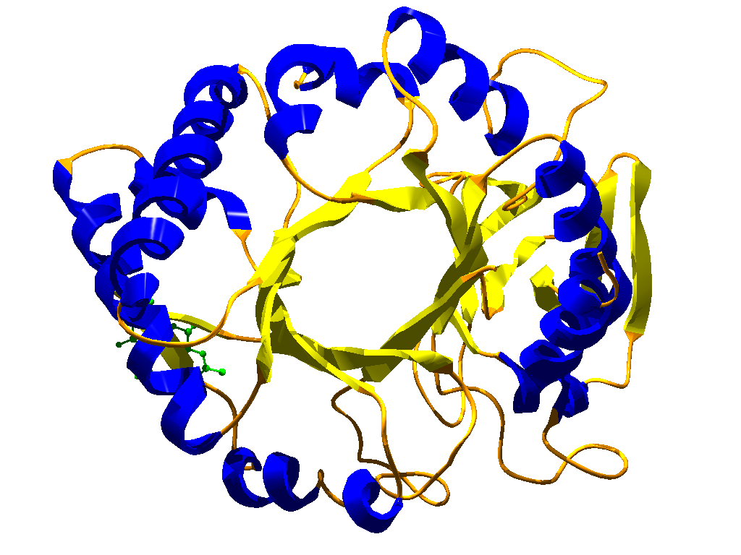
Recently, we have determined the structures of new regulatory proteins named as SPX-40. The precise functions of these proteins are not yet known. However, they are assumed to be involved in the protection of certain breast cancer cells, thus making the treatment of breast cancer ineffective. The isolation, purification, crystallization and structure determination of these proteins have been achieved from human, goat, sheep and bovine mammary glands. They have also been cloned. It is intended to develop inhibitors of this class of proteins so that their binding could be impaired and the cancer cells could be destroyed by separate processes.

7. Cobra Venom Factor
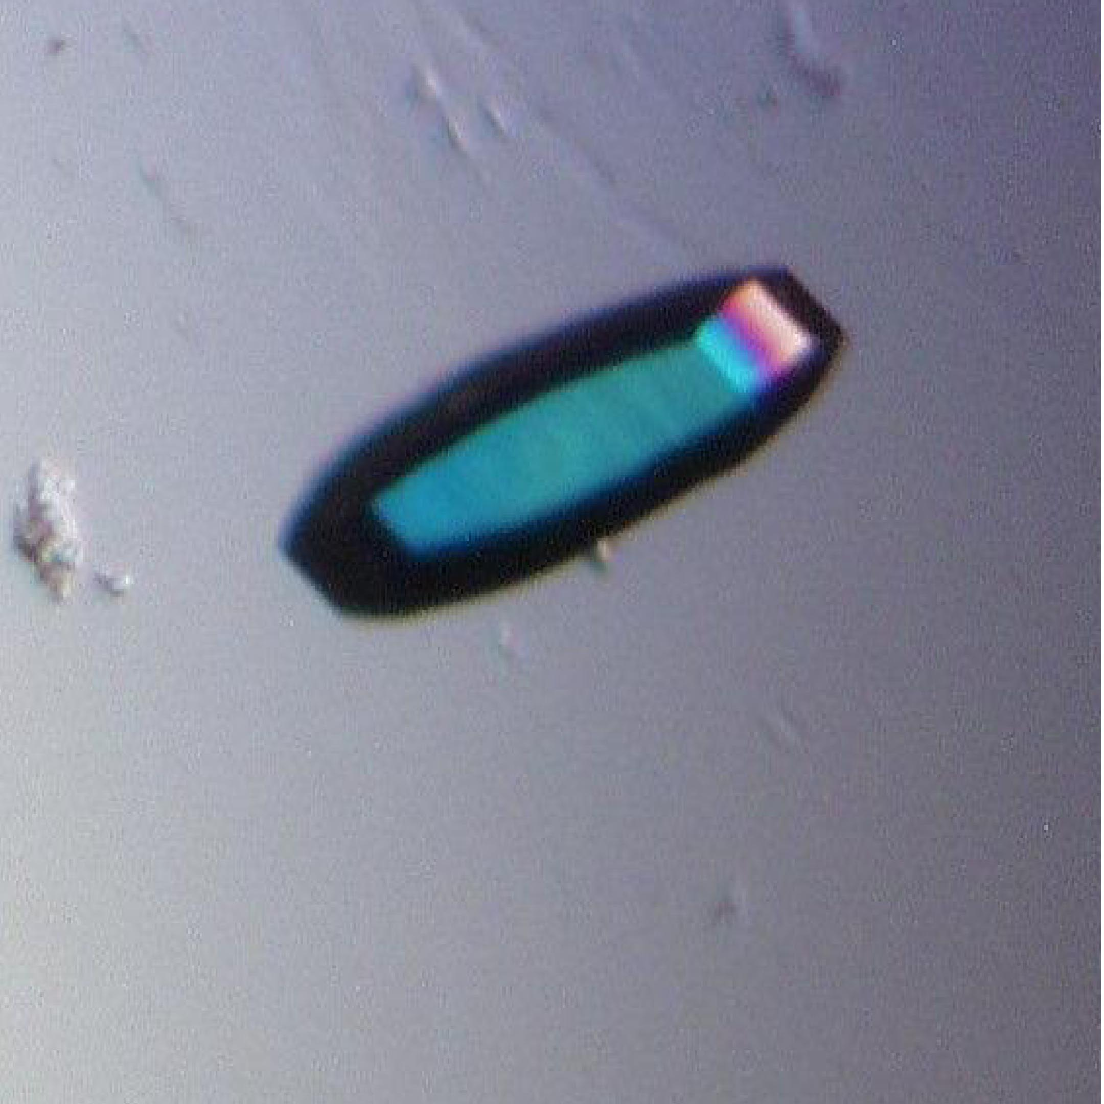
Cobra venom factor (CVF) is the complement-activating protein in cobra venom. It is a three-chain glycoprotein with a molecular weight of 149,000 Da. In serum, CVF forms a bimolecular enzyme with the Bb subunit of factor B. The enzyme cleaves C3 and C5, causing complement consumption in human and mammalian serum. CVF is frequently used to decomplement serum to investigate the biological functions of complement and serves as a tool to investigate the multifunctionality of C3. Furthermore, CVF bears the potential for clinical application to deplete complement in situations where complement activation is involved in the pathogenesis of disease. CVF has been isolated from Indian cobra (Naja naja naja) venom, crystallized and the preliminary crystallographic data determined.

8. Proteins of Alzheimer’s Disease
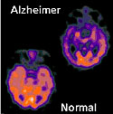
We are also interested in the structural biology of Alzheimer’s disease. We have cloned the Abeta precursor protein, presenilin and BACE proteins. The crystallographic investigation on the latter two proteins are critical in designing inhibitors of proteolytic enzymes involved in Abeta 1-40, 1-42 mer production. Besides these studies, we are also engaged in studying the aggregation of the Abeta 1-42 mer in vitro. Shorter peptides designed to have an extended conformation are proposed to be tested for their intervention of  sheet formation by Abeta peptides.

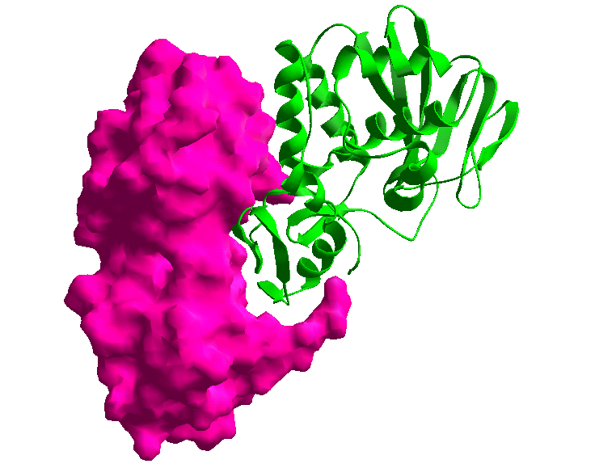
9. Ribosome inactivating proteins
Ribosome inactivating proteins (RIPs) are cytotoxins which can inhibit protein synthesis by inactivating ribosome. There are two types of RIPs. A type-I RIP is a single polypeptide with molecular weight of 25-30kDa. A type-II RIP consists of a toxin-part chain (A-chain) and a lectin-part chain (B-chain) bound by a disulphide bond. The crystal structure of the ribosome-inactivating protein mistletoe lectin I (ML-I) from Viscum album has been solved by molecular replacement techniques. The structure has been refined to a crystallographic R-factor of 24.5% using X-ray diffraction data to 2.8 A resolution. The heterodimeric 63-kDa protein consists of a toxic A subunit which exhibits RNA-glycosidase activity and a galactose-specific lectin B subunit. The overall protein fold is similar to that of ricin from Ricinus communis; however, unlike ricin, ML-I is already medically applied as a component of a commercially available misteltoe extract with immunostimulating potency and for the treatment of human cancer. The three-dimensional structure reported here revealed structural details of this pharmaceutically important protein. The comparison to the structure of ricin gives more insights into the functional mechanism of this protein, provides structural details for further protein engineering studies, and may lead to the development of more effective therapeutic RIPs.

10. Peptide Design and Synthesis
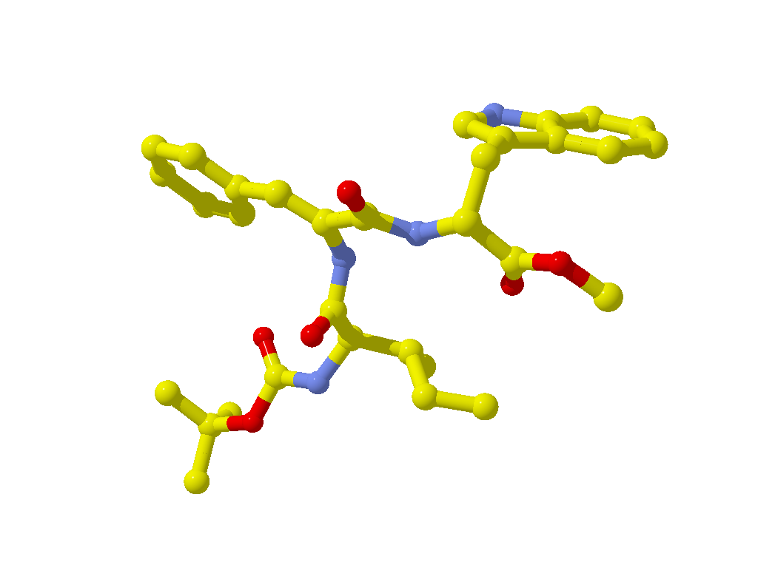
The conformational preferences of amino acid side chains are of fundamental importance in determining the interactions that govern the preferred conformations of polypeptides and proteins. The conformational preferences are governed to a large extent by interactions of the atoms of a given side chain with atoms of the backbone as well as the atoms of the two neighbouring peptide units. Thus, the peptides can adopt a large number of conformations in order to gain preferred side chain-backbone and side chain - side chain interactions. This makes the design strategy rather weak and impractical. In order, to develop an effective design tool, it is necessary to restrict the number of preferred conformations to the minimum. Furthermore, these conformations must be guided by well defined steric effects so that accurate predictions can be made using these effects.
α,β-unsaturated or (-dehydro-) residues have emerged as an effective tool in the design of precise secondary structures of peptides and proteins. These have been found to occur naturally in antibiotics of microbial origin and in some proteins. Peptides containing α,β dehydro-residues are synthesized in ribosome via a precursor protein followed by enzymatic modifications. The side chains of various dehydro-amino acids offer constraints of differing magnitudes to modulate the backbone conformations. With an intention to develop the schemes of peptide design using α,β -dehydro-amino acid residues, we have initiated a programme of systematic investigations on dehydro-residue containing peptides. The most detailed and systematic investigations on conformational characteristics of dehydro-residue containing peptides have been carried out in solid state using X-ray diffraction method. The structures of 50 dehydro-residue containing peptides have been analysed so far.

